General Purpose Mounting Block A
Version 1.0

Project Goals
I need to create a block that can rotate 90 degree the fixing screw angle.
I need something that fit into the Kaiser Stand Bracket and let me fix something from the bottom.
This is Block A, this is the first I created and it is quite big.

Sketch

Side view
This is how the block is connected to the Kaiser Stand Bracket
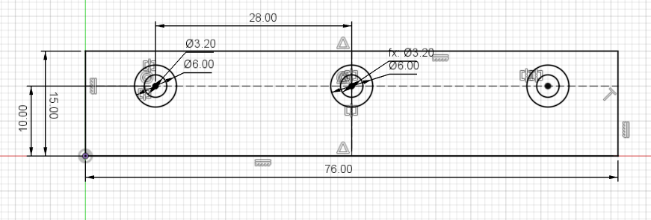

Top View
The 2 holes are for the object connection and the distance is 28 mm

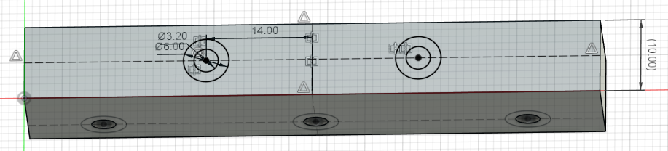

3D Model
The block is 15 x 10 mm
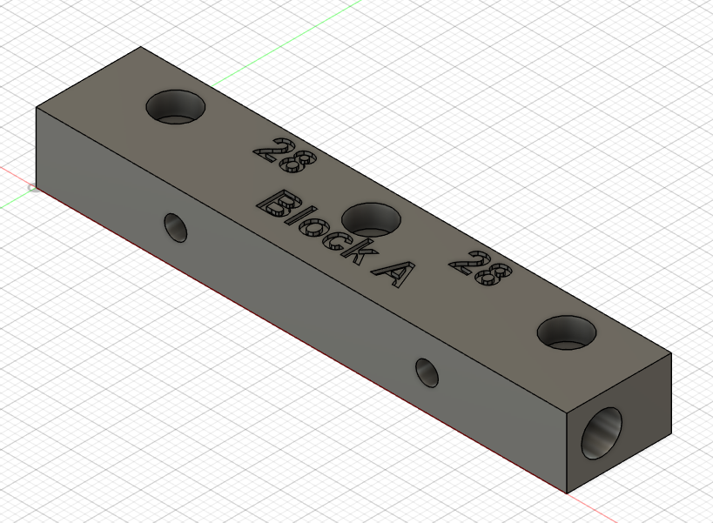

3D Printer Layout
PLA Print Time: 21 min
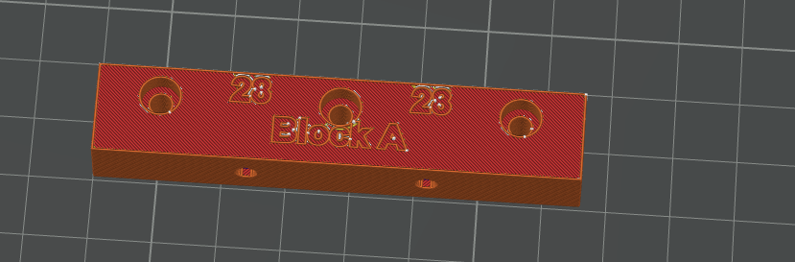

Final result

Reference

Kaiser Stand Bracket
This component is to be used with the KaiserStandBracket v3.0.
